Whānau Voice Grant – Application Form

Applicants must complete and submit the official application form by the closing date:
Online Application: 04th May 2026, 11:59PM
Email Application: 04th May 2026, 11:59PM
Post: P.O Box 4064, Newtown, Wellington, 6424
In-person office: 04th May by 4 pm at our office 45 Rugby Street, Mount Cook - Level 1, Suite 1
Project Start/Completion dates must fall within: 1 June 2026 – 16 October 2026
All applicants will be contacted on Monday, 18th May 2026, with the outcome of their Whānau Voice Grant application.
PLEASE DO NOT CHANGE OR DELETE ANY OF THE CONTENT WITHIN THIS APPLICATION UNLESS SPECIFIED
Applications to be submitted by email: grants@atiawatoaimpb.nz

All applicants will receive written confirmation of receipt.
Late or incomplete applications will not be considered.

If you have any questions or need support completing your application, please contact us at grants@atiawatoaimpb.nz

Whānau Voice Grant

Eligibility
This section helps us understand who is applying and provides a quick overview of your kaupapa. It also helps confirm that your project aligns with our eligibility requirements.
We (Āti Awa Toa Hauora Partnership Board) receive funding to support the health and wellbeing of whānau within our rohe. Funding must be used for activities delivered within this region and for gathering whānau voice from Māori who live in the Āti Awa Hauora Partnership Board region” (see map).
This ensures the funding directly benefits the communities it is intended to support.
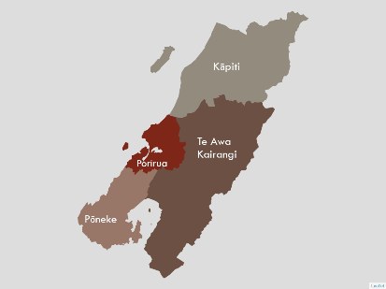
- Will your project take place within the Āti Awa Toa Hauora Partnership Board region? (required – Highlight your answer)
Refer image above for the region boundaries
- Yes
- No (Not Eligible)

- Will your project engage whānau who live in the Āti Awa Toa Hauora Partnership Board region? (One selection required – highlight your answer)
Refer image above for the region boundaries
- Yes, participants live in the region
- I don't have any participants yet, but I plan to engage whānau from the region
- No, some (or all) live outside of the region (Not Eligible)

Note: Whānau Voice Grants are intended to support initiatives that take place and engage whānau living within the Āti Awa Toa Hauora Partnership Board region.
If you have selected “No” to either of the questions above, indicating that your project will not take place in this region or involve whānau from this region, your application does not meet the eligibility criteria for this funding round.

Please review your responses carefully before continuing or discontinue the application.

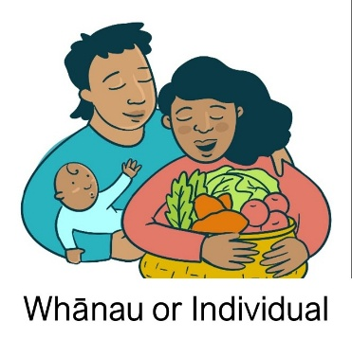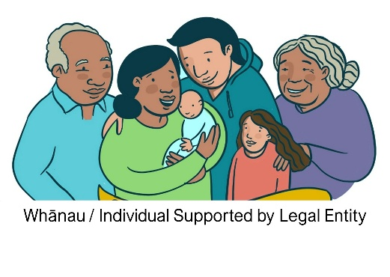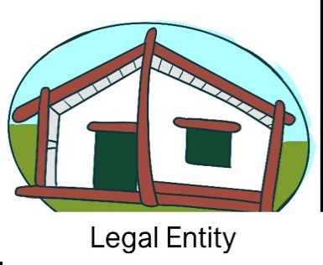

- What type of applicant are you: (Required – highlight your answer)

- WHĀNAU OR INDIVIDUAL (NOT A REGISTERED LEGAL ENTITY)
Important Notice for Funding for Whānau or Individuals. If you are applying as a whānau or individual without the support of an umbrella organisation, please note that grant funds cannot be paid directly into a personal bank account. In this situation, successful applicants will be required to forward supplier or service invoices to Āti Awa Toa Hauora Partnership Board who will arrange payment on your behalf. This process ensures accountability and proper administration of grant funding while still supporting whānau-led initiatives.

- WHĀNAU OR INDIVIDUAL (SUPPORTED BY A LEGAL ENTITY)
If you have selected to apply as a whānau whose funding will be received and administered by a registered organisation, trust, or company. The nominated legal entity will act as the fund holder and will be responsible for financial management and accountability; however, all project reporting requirements and milestones associated with the grant will remain the responsibility of the whānau applicant/s.
As your project is being supported by a legal entity, that organisation must provide the following documents:
- A letter of support (on official letterhead or an email) clearly stating their agreement to receive and administer the funding on behalf of your project.
- A copy of their legal entity registration certificate
- A bank account verification (e.g. deposit slip or bank confirmation)
- Their most recent annual financial report or performance report to verify their annual revenue is less than $140,000, and they must not have public accountability.

Please ATTACH these supporting documents to your application.

- LEGAL ENTITY
Choose this if you are applying as a registered organisation, trust or company and will directly receive, manage and report on the funding.
This section applies to applicants who are a registered organisation, trust, incorporated society, or company applying directly for funding.
Legal Entity Name (Required)

Registration number (Required)

Address (Required)

Is the legal entity GST registered? (Required)
- Yes (please provide GST #)__________________________________________________
- No
Consent (Required)
- I confirm that I am authorised to apply for this grant on behalf of the legal entity.

- Is this application part of an existing programme that already receives funding, or is it aligned with your current paid employment? (Required – highlight your answer)

- NO

- YES
(If yes, please provide more details about the existing program that this funding will support)

Application Information
Contact Person First Name (Required)

Contact Person Last Name (Required)

Contact Person Email Address (Required)

Contact Person Phone Number (Required)

Applicant Name (Whānau or Individual) (Required)

PROJECT DETAILS & WHĀNAU VOICE ALIGNMENT (20 POINTS)
This section assesses the clarity of your kaupapa, alignment with Te Āti Awa Toa Hauora Partnership Board health priorities, and how whānau voice is gathered and upheld.
- What is the title of your project? (Required)

- Kaupapa Description. Please describe your kaupapa, the need or opportunity it responds to, and what you aim to achieve. (Required)
Helpful Guidance:
- Share the story or whakaaro behind your kaupapa
- Explain what inspired this project or what need or opportunity it responds to
- Describe what you want to achieve or change through this kaupapa
- Consider what success would look like for whānau involved
- Outcomes can include cultural, social, or wellbeing improvements — not just clinical health outcomes.

[type your answer here and delete this message]

- Whānau Voice Alignment (Required)
How will your project gather, uplift, or share whānau voice in relation to health and wellbeing?
* Helpful Guidance:
- Explain how whānau will share their experiences, knowledge, or aspirations
- You may use approaches such as hui, kōrero, interviews, surveys, or creative storytelling
- Consider how whānau voice will be recorded or shared

[type your answer here and delete this message]
- Which health priority does your project align with? (Required – highlight answer)
Please select the priority area your project most strongly supports:

- Heart Disease
- Cancer
- Obesity
- Diabetes
- Other

- Who is your intended audience? (Required – highlight answer)
This is the group of people you aim to engage.

- Whānau (rangatahi, pākeke, kaumātua)
- Hapū
- Iwi
- Hāpori
- Other

- How many people are expected to participate? (Required – highlight answer)
Participant numbers can be an estimate. This helps us understand the scale of your Kaupapa

- 0-10
- 11-20
- 21-30
- +31
- WHĀNAU LEADERSHIP & CULTURAL INTEGRITY (20 points)
This section helps us understand who is leading the kaupapa and how tikanga, mātauranga Māori and whānau values guide the design and delivery of your project.
Project Leadership
- Who is leading and supporting this kaupapa, and what roles will they hold? (Required) (For example: coordinator, facilitator, video editor). You may add more than one person.
[type your answer here and delete this message]

Kaupapa Māori Design (Required)
- How is your project guided by kaupapa Māori, tikanga or mātauranga Māori (Required)
* Helpful guidance:
- Describe how cultural values or practices shaped how your kaupapa is delivered.
- You may include examples of tikanga, or cultural approaches used during engagement
[type your answer here and delete this message]

- DESIGN, FEASIBILITY and budget appropriateness (20 POINTS)
Explain how your project will operate in practice. We are looking for clear planning, achievable timelines, defined responsibilities, and realistic delivery methods.
IMPORTANT INFORMATION – Projects must be completed with the approved funding period (1 June 2026 – 16 October 2026)

- Project Start Date (Required)
Provide your planned start date. This can be an estimate.

- Project End Date (Required)
Provide your expected completion date. Consider time needed to finalise deliverables.

Activities & Timeline (Required)
- Please outline the key activities, milestones and timeframe for your project.
* Helpful guidance
- Break your kaupapa into clear steps or stages
- Include when key activities will happen
- Consider preparation, delivery and follow-up activities

[type your answer here and delete this message]

Project Methods (Required)
- How will your project be delivered in practice? Describe the methods you will use to gather whānau voices and carry out your activities.
* Helpful guidance:
- Explain how activities will take place. For example, hui, marae-based wānanga, one-on-one interviews, online hui, storytelling, surveys, workshops
- Describe how participants will be engaged

[type your answer here and delete this message]

Budget (Required)
This section assesses whether your budget is realistic, clearly explained, and directly aligned with your project activities. You may request up to $5,000 through the Whānau Voice Grant
Budget Guidance
- Requested Amount – The amount you are requesting from the Whānau Voice Grant. The maximum request is $5,000.
- Other Funding Amount – Any support for your kaupapa that is not from the Whānau Voice Grant, for example, your own money, donations and sponsorship
Proposed Budget (Required)
Item Description | Quantity | Unit Cost | Total
Total

- INNOVATION & IMPACT (20 POINTS)
This section considers the potential difference your kaupapa may make for whānau, communities and future health planning. We welcome creative and innovative approaches that strengthen whānau voice and support positive change in health and wellbeing.
- What difference do you hope this kaupapa will make for whānau, communities, or future health planning? (Required)
* Helpful guidance:
- Think about both short-term and long-term benefits for whānau or communities
- Describe how whānau may feel supported, empowered or better connected
- Consider how your kaupapa could improve health and wellbeing experiences
- You may also describe how the learnings from your project could help improve services or influence future health planning

[type your answer here and delete this message]

- What is innovative or unique about your approach, if anything? (Required)
* Helpful guidance:
- Think about what makes your kaupapa different or special.
- This could include creative, cultural, or community-led approaches
- Innovation does not have to involve technology — it may include new ways of engaging whānau or sharing stories
- You can also describe if your kaupapa builds on existing work in a new or improved way
[type your answer here and delete this message]

- ETHical practice (20 POINTS)
This section assesses how you will protect whānau voice through respectful engagement, cultural safety, informed consent and responsible management of information gathered through your kaupapa.
How will you ensure whānau voice is gathered, stored and shared safely and respectfully? (Required)
* Helpful guidance
- Outline how information will be stored, used, shared or returned to whānau
- Consider how information will be stored, shared or returned to whānau
- Formal systems are not required – simple, clear and respectful processes are appropriate
- Consider how you will ensure participants feel safe and supported when sharing their experiences
[type your answer here and delete this message]
- Supporting Documents
Legal Entity Documents (Required)
Please attach a legal entity certificate, bank verification slip (this can be a copy of a bank deposit slip or a screenshot of your account)
Additional Supporting Documents (optional)
You may also choose to attach additional supporting documents such as letters of support, project plans or images. These additional documents are not compulsory but can help strengthen your application.

- CONSENTS AND DECLARATIONS
Media and Content Use (Required)
- I acknowledge that content created through this kaupapa may be used by for Āti Awa Toa Hauora Partnership Board for communications, social media and reporting purposes, subject to signed media consent or waiver forms
Application Accuracy and Reporting (Required)
- I confirm that the information provided in this application is true and correct. If successful, I agree to provide a final report, including receipts and evidence of activities undertaken
Original Content (Required)
- I confirm that all content, stories and materials submitted through this kaupapa will be original or used with appropriate permission and will not infringe on the rights of others

Sign: __________________________________________________ Date: ___________________________________

Overall, how easy or difficult was this application for to complete? (Provide a comment below)
- 1
- 2
- 3
- 4
- 5
Very easy 1 → Very difficult 5

